PR19 Business Plan Presentation Pro-forma – August 2018 update

Briefing for Ofwat Non-Executive Directors and senior leadership
As indicated in our final methodology for the 2019 price review (PR19) published in December, this pro-forma draws together high level information and key metrics from the business plan and explains the drivers behind the business plan, the key benefits for customers and the impact on customer bills.
The pro-forma has been developed to support discussion at the PR19 business plan presentations taking place during September-October 2018, and to ensure a consistent approach across companies to briefing Ofwat board members for these. The pro-forma will be provided to Ofwat Board members and senior leadership ahead of these presentations. These presentations will not form part of our initial assessment of business plans process, nor are a substitute in any way for business plans.
The presentations are scheduled for an hour, with a presentation of 15 minutes followed by up to 45 minutes for questions and discussion. These presentations provide an opportunity for companies to set out their business plans to Ofwat, including Ofwat Board members. We do not expect companies to use this pro-forma as the basis for the presentation itself.
For PR19, we expect companies to deliver an ambitious business plan that delivers on our four key themes of innovation, great customer service, affordability and increased resilience. We are expecting companies to challenge themselves in these areas, and this pro-forma and the business plan presentations provide an opportunity for companies to demonstrate how they are meeting this challenge.

Guidance on completing the pro-forma
To support companies in completing this pro-forma, we have published guidance tables which include references to the relevant PR19 business plan tables to draw the information requested from. Where the information requested is not held in PR19 business plan tables, we have indicated where this should be drawn from by companies (for example, the PR14 final determination). The PR19 bill movement model has also been published in order to complete the bill movement waterfall chart (table 2.1).

Submission of pro-forma to Ofwat
We expect companies to submit the completed pro-forma, guidance tables and PR19 bill movement model to Ofwat along with PR19 Business Plans by 5pm Monday 3 September 2018.

Publication of the completed pro-forma
As outlined in our final methodology, to improve transparency we want companies to make their business plans available to us, companies, customers, stakeholders and other regulators. We therefore expect them to publish the whole of their business plans at the same time as they submit their plans to us in September 2018. We ask that companies publish their completed pro-forma, guidance tables and PR19 bill movement model alongside their business plans as well as submitting these to us on 3 September 2018.
If a company considers some information should not be published – because it is commercially sensitive information, for example – then the company will need to provide its stakeholders and us with strong, robust reasons that are specific to the information concerned.

Contents
Contents 3
1. Background 4
1.1 Company pen pic 4
1.2 List of attendees 4
2. Key business plan metrics 5
3. Appendices 10
Appendix 1: Attendee biographies 11
Appendix 2: Business plan executive summary 12
Appendix 3: CCG report executive summary 13
Appendix 4: Current operational performance 14
Appendix 5: PR19 proposed performance commitments 17
Appendix 6: Expenditure 19
Appendix 7: Trust, Confidence and Assurance 20

1. Background

1.1 Company pen pic
[insert company name] is a [water only/water and wastewater] company located in [add].
Please provide a short summary of the ownership structure of the company, including whether there have been any changes to this since 2014 [max. 150 words].

1.2 List of attendees
Please provide the names and job titles of attendees for the business plan presentation meeting. Please note there is an opportunity to provide more detailed attendee biographies in Appendix 1.

2. Key business plan metrics
PR19 key themes
Please set out here how you consider the approach you have taken to your business plan is consistent with the key themes for PR19 of innovation, great customer service, affordability and increased resilience. Where relevant, you may wish to additionally link this to information included elsewhere in this pro-forma [max. 300 words].
Table 2.1: Waterfall chart
This chart provides an overview of what is driving changes to bills between 2019-20 and 2024-25. The inputs to the waterfall chart are in price base 2017-18 year average CPIH deflated. We have published the PR19 bill movement model in order for companies to developed the waterfall chart.
Example table – inputs to example bill movement chart
Inputs | £ per customer
2019-20 Bill | 300
Changes between 2019/20 and 2024/25
Change in RCV | 5
Change in RCV run-off | 5
Change in WACC | -50
Change in customer numbers | -10
Change in totex | 5
Change in PAYG rate | 15
Change in other wholesale items | 5
Change in retail CTS | -7
Change in reconciliation items | -20
2024-25 Bill | 248
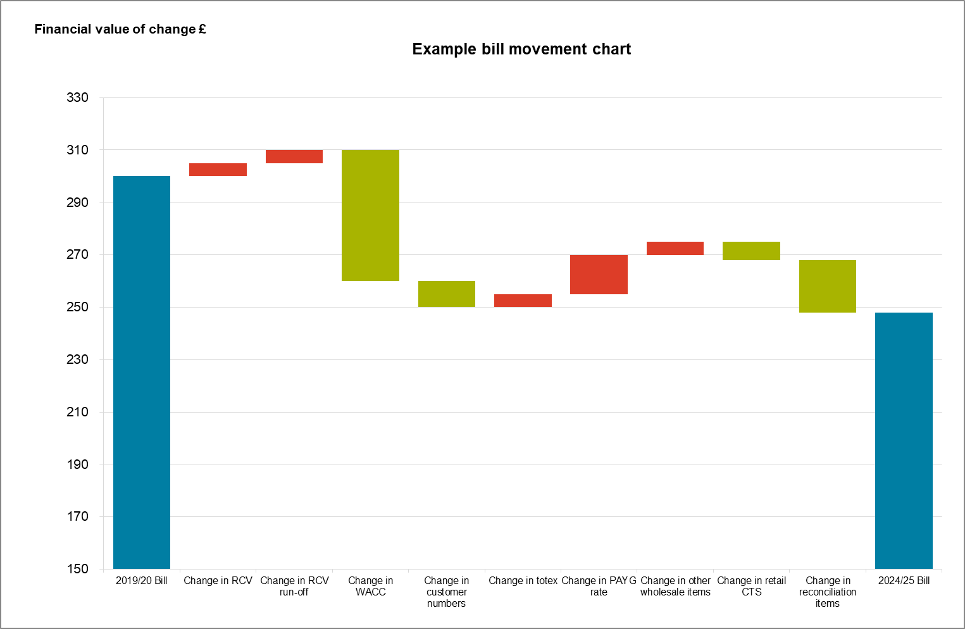
Explanation of movement in customers’ bills
Please set out the key factors that are driving the movement in customers' bills from PR14 to PR19 [max. 200 words].
Customer Expectations
Please provide a brief summary of your understanding of your customers’ expectations and preferences for your business plan. [max 300 words].

Table 2.2: Key business plan metrics
Metric | PR14 (2019-20)  31 March 2020 estimate | PR19 (2024-25)  31 March 2025 estimate | 2019-20 to 2024-25  % change  (leakage and PCC)
Number of residential water only customers (000s)
Number of residential wastewater only customers (000s)
Number of residential water and wastewater customers (000s)
Total leakage (Ml per day)
Based on PR19 definition, annual average
Leakage (cubic metres per km of main per day)
Based on PR19 definition, annual average
Leakage (litres per property per day)
Based on PR19 definition, annual average
Per Capita Consumption (PCC)
Based on PR19 definition, annual average
ODI RoRE range
Appointee WACC (real RPI)
Appointee WACC (real CPIH)
Credit rating – actual financial structure
Metric | PR14 (2015-2020 Average) | PR19 (2020-25 Average)
Adjusted interest cover notional
FFO net debt notional
Metric | 2017-18 Actual | PR19 (2020-25 Average)
Actual gearing
Adjusted interest cover actual
FFO net debt actual
Commitment to financial resilience
Please set out here how you will maintain commitment to financial resilience [max. 150 words].

Table 2.3: RCV
Control | 1 April 2020 (£m)  Opening RCV  2017-18 FYA (CPIH deflated) | 30 March 2025 (£m)  Closing RCV  2017-18 FYA (CPIH deflated) | % growth
Water resources RCV
Water network Plus RCV
Wastewater network Plus RCV
Bioresources RCV
Table 2.4: Dividends
Metric £m  Outturn (nominal prices) | 2015-16 | 2016-17 | 2017-18
Dividends (based on PR14 actual company structure)
Outturn (nominal prices) | 2020-21 | 2021-22 | 2022-23 | 2023-24 | 2024-25
Dividends (based on PR19 actual company structure)
Dividend Policy
Please provide a short statement here on your company’s dividend policy [max. 150 words].

3. Appendices

Appendix 1: Company presentation attendee biographies
Please include biographies for all company presentation attendees, including the Customer Challenge Group Chair (if attending).
[Max. 100 words per attendee]

Appendix 2: Business plan executive summary
Please provide a copy (in file formats that can be opened in word) of the executive summary for your business plan.

Appendix 3: CCG report executive summary
Please provide a copy (in file formats that can be opened in word) of the executive summary from the CCG report on your company.

Appendix 4: Current operational performance
Table 4.1: PR14 Performance Commitments
Please indicate in the table below which PR14 performance commitments have been met and which have not been met over the PR14 period. This table is not for Service Incentive Mechanism (SIM) data, for which table 4.2 has been provided. For financial ODIs please also indicate total forecast outperformance payment or underperformance penalty for the PR14 period.
No. | ID  (eg W-A1) | Performance commitment | 2015-16  PCL met? | 2016-17  PCL met? | 2017-18  PCL met? | 2018-19  PCL met?  (forecast) | 2019-20  PCL met?  (forecast) | Cumulative ODI  (outperformance payments or underperformance penalties)  £m to 4 decimal places  2012-13 prices, net of tax
 |  |  |  |  |  |  |  | 15/16-17/18 Actual | 18/19-19/20  Forecast
1
Total cumulative financial ODI
Table 4.2: PR14 Service Incentive Mechanism (SIM) Performance
SIM Performance | 2015-16 | 2016-17 | 2017-18
Total annual SIM score (out of 100)

Appendix 5: PR19 proposed performance commitments
Table 5.1: Common Performance Commitments
No. | Common performance commitment | ID (eg W-A1) | 2019-20  forecast performance level  (where relevant) | 2024-25  proposed performance commitment level | ODI type | In period /  end of period ODI | 2019-20 to 2024-25  % change  (leakage and PCC PCs)
1 | Water quality compliance – the DWI’s Compliance Risk Index (CRI), a score greater than or equal to zero, where zero is least risk
2 | Water supply interruptions – average supply interruption greater than 3 hours (minutes per property)
3 | Mains bursts – number of water mains bursts per 1,000 kilometres of total length of mains
4 | Unplanned outage – proportion of unplanned outage of the total company production capacity (%)
5 | Leakage – megalitres per day (Ml/d), three-year average
6 | Per capita consumption – average amount of water used by each person that lives in a household property (litres per person per day), three-year average
7 | Risk of severe restrictions in a drought – percentage of the population the company serves that would experience severe supply restrictions (e.g. standpipes or rota cuts) in a 1-in-200 year drought
8 | Treatment works compliance – % compliance with environmental permits at water and wastewater treatment works (EA’s Environmental Performance Assessment definition)
9 | Internal sewer flooding – number of incidents per year (sewerage companies only)
10 | Sewer collapses – number per 1,000 kilometres of sewer (sewerage companies only)
11 | Pollution incidents – category 1-3 pollution incidents per 1,000km of sewerage network, as reported to the Environment Agency and Natural Resources Wales (sewerage companies only)
12 | Risk of sewer flooding in a storm – percentage of population at risk of sewer flooding in a 1-in-50 year storm (sewerage companies only)

Appendix 6: Expenditure
Table 6.1: Totex
Total expenditure | Price Base | PR14 final determination 2015-2020 | Proposed for PR19  2020-2025
Water network plus (£m) | 2017-18 FYA (CPIH deflated)
Water resources (£m) | 2017-18 FYA (CPIH deflated)
Wastewater network plus (£m) | 2017-18 FYA (CPIH deflated)
Bio resources (£m) | 2017-18 FYA (CPIH deflated)
Residential retail costs | Outturn (nominal prices)
Table 6.2: Direct Procurement for Customers (DPC) proposals
No. | Project name | Total project cost (£m)  2019-20 to 2049-50  2017-18 FYA (CPIH deflated)

Appendix 7: Trust, confidence and assurance
Please explain how the company’s full Board has demonstrated that its governance and assurance processes will deliver operational, financial and corporate resilience over the next control period and the long term.
Please explain how the company’s full Board has assured themselves that the business plan will enable trust and confidence, including how the company’s Board has taken account of the decisions Ofwat set out in its decisions for PR19 business plans to put the sector in balance.
[max. 400 words]

PCL met? - if the performance commitment level (PCL) for the reporting year was met, or is forecast to be met, enter ‘Yes’. If the PCL for the reporting year was not met, or is forecast not to be met, enter ‘No’. If a PCL has not been set for the reporting year enter "-" (hyphen).
This table includes all PR19 common performance commitments with the exception of C-Mex and D-Mex, as the design of these is different.

